

CS3343 Software Engineering Practice
Project Plan Report (Group 5)
Project Title: Sport Facility and Equipment Booking System

Name | Student Number
NG Ka Hung | 58533046
LIN Weiyuan | 58537684
LAU Wing Him | 58537137
IP Wing Kai | 58120400
LEE Kin Wai | 57925345
Chan Sing To | 58533974

Table of Content
1.1. Background 3
1.2. Introduction 3
2.1. PROJECT OBJECTIVES 4
2.2. Project Organization 5
2.2.1. Organization Structure 5
2.2.2. Organization Description 5
2.3. Project Stakeholders 6
2.4. WBS 7
2.5. Gantt Chart 8
2.6 SCHEDULE 9
2.7 Software Development Methodology 10
2.8 Software Configuration 10
2.9 Use of Technologies and platforms 10

1.1. Background
As public awareness of health increases and the concept of fitness becomes more widespread, the demand for sports facilities is also growing. However, traditional booking methods, such as telephone booking and on-site registration have many problems, such as poor service quality, time slot conflicts, long waiting times, and inconsistent payment methods. Equipment sales and rental, meanwhile, are usually disentangled from booking a venue, resulting in discrepancies in stock, complex settlements, and poor user experiences. At universities, neighborhoods, and professional campuses, time preference and price sensitivity among consumer groups vary which only adds to the complexity of the management. To counter these, it is high time to develop an integrated platform to integrate login or registration, password recovery, book the venue, equipment rental and sales, shopping cart/payment, order records, permissions and membership discount. Such a platform would digitize and visualize processes that touch on everything from resources’ display and conflict detection to stock validation to payment and settlement resulting in lower overhead costs, greater resource use and consumer satisfaction.

1.2. Introduction
SportApp is a campus- and community-tailored sporting venue booking and rental integrated application. It enables secure account login/registration with security-question-based password recovery; venue booking with conflict resolution and time-slot management; immediate equipment borrowing and merchandising; shopping cart visibility of pending payments; order inquiry and amendment; and electronic payment (ex: Octopus). The platform uses a modular structure with centralized managers with unified care of facilities and equipment, the booking records being structured with data models showing status “Pending Payment”, “Completed” and “Ended”. Users update their date/time and location of current booking or cancel with confirmation; successful payment is when records are turned into completed orders and stored as transaction logs. The platform offers discounts per tier, hourly rates, and safe undo/redo push notifications so that abnormal flows can be triggered. Through its intuitive interactions and solid validation, SportApp provides high usability, scalability and scalability all while drastically increasing booking efficiency and increasing booking and service experience.

2.1. PROJECT OBJECTIVES
The main objectives of the project are to:
(a) Provide a comprehensive and centralized system for booking sports facilities and managing equipment.
A robust management system is vital for a sports center to streamline operations and enhance user access. It is hoped that SportApp can aid users in easily booking facilities and renting/purchasing equipment, reducing manual administrative workload and improving the overall user experience.
(b) Allow secure user authentication and account management.
To enable users to manage their own bookings, a secure and simple authentication process is required. The program must allow users to Login, Register a new account (with a security question), and Reset their password, ensuring that all booking records are tied to a specific, verified user.
(c) Create distinct modules for facility booking, equipment rental, and booking management.
The program should be able to process and manage different types of user requests. By separating core functions—such as Facility Booking, Equipment Rental and Sales, and viewing a Pending Booking (shopping cart)—the program can provide a clear workflow. This allows users to add items, review them, and make modifications (update/cancel) before final payment.
(d) Process user inputs, validate availability, and prevent booking conflicts.
User requests for facilities or equipment may contain scheduling conflicts (e.g., booking an already-taken timeslot) or inventory issues (e.g., renting more equipment than is in stock). The program must validate all inputs against available resources, provide clear error messages ("The answer is wrong," "inventory quantity < input quantity"), and implement a "booking crash checking mechanism" to ensure data integrity.

2.2. Project Organization
This project consists of different people to make this come true. In this section, it illustrates how different roles have been assigned to different group members.

2.2.1. Organization Structure
Project Manager
Assistant Project Manager
Program Developer
Program Developer
Program Developer
Program Tester

2.2.2. Organization Description
Role | Name | Description
Project Managers
Project Manager | Ng Ka Hung, Simon | The manager of the project and responsible for planning, identifying project goals and leading the direction of the project.
Assistant Project Manager | Lau Wing Him, Curtis | Assistant of Project Manager
Programmer
Program Developer | Ip Wing Kai, Paul | The people who are responsible for developing the system, fixing bugs.
Program Developer | Chan Sing To, Tommy
Program Developer | Lee Kin Wai, Vincent
Program Tester | Lin Weiyuan, Ivan | Who is responsible for testing the system, ensuring the system has no issue for normal user uses.

2.3. Project Stakeholders
Stakeholders | Description
Users of the Sport Centre | Before with the sport centre system implemented, the user had to do booking or buying with staff in the sport centre, and it could be inconvenient. With the system implemented, the user can buy equipment, book equipment and facility manually.
Campus Owner | The owner who owns the campus. With the sport centre system in control, they can hold the record of equipment and venue without manual help.
Development Team | The development team is responsible for developing and maintaining the program.

2.4. WBS
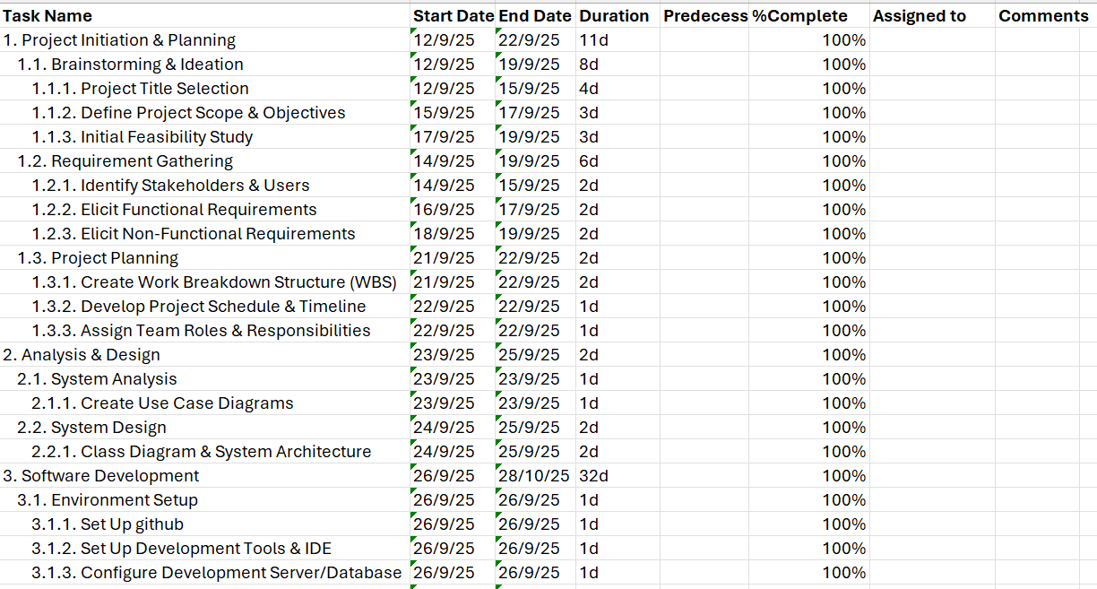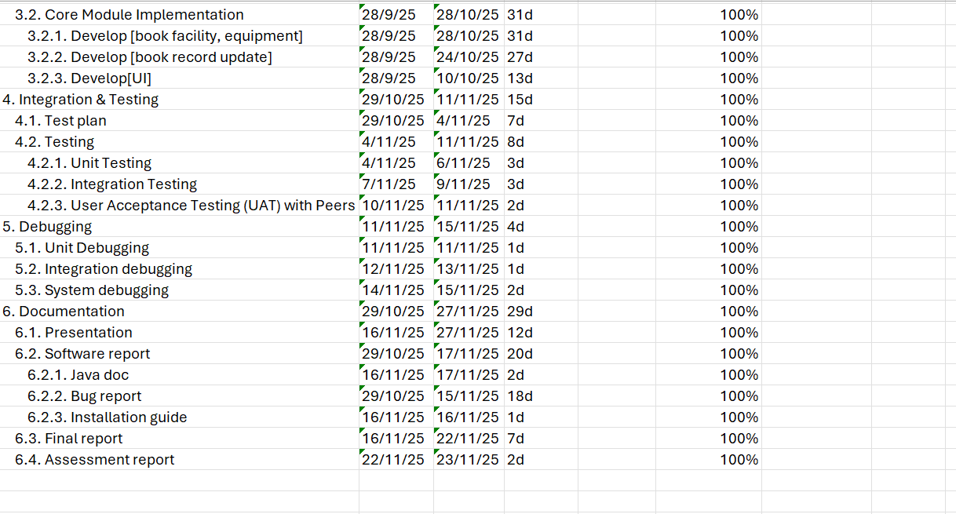

2.5. Gantt Chart
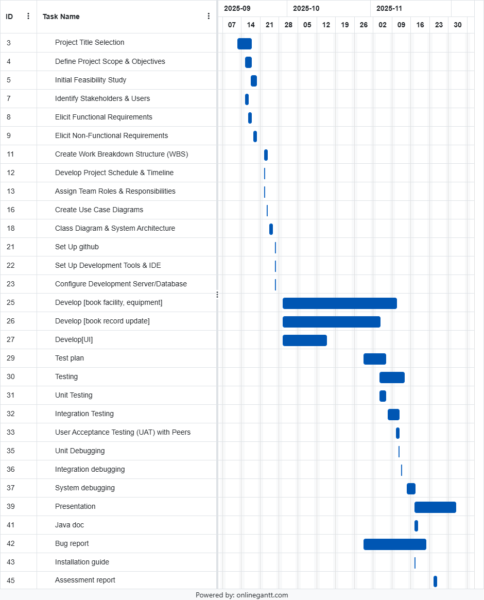

2.6 SCHEDULE
Tasks | Start Date | End Date
1. Project Initiation & Planning
1.1. Brainstorming & Ideation | 12 SEP 2025 | 19 SEP 2025
1.2. Requirement Gathering | 14 SEP 2025 | 19 SEP 2025
1.3. Project Planning | 21 SEP 2025 | 22 SEP 2025
2. Analysis & Design
2.1. System Analysis | 23 SEP 2025 | 23 SEP 2025
2.2. System Design | 24 SEP 2025 | 25 SEP 2025
3. Software Development
3.1. Environment Setup | 26 SEP 2025 | 26 SEP 2025
3.2. Core Module Implementation | 28 SEP 2025 | 28 OCT 2025
4. Integration & Testing
4.1. Test plan | 29 OCT 2025 | 4 NOV 2025
4.2. Testing | 4 NOV 2025 | 11 NOV 2025
5. Debugging
5.1. Unit Debugging | 11 NOV 2025 | 11 NOV 2025
5.2. Integration debugging | 12 NOV 2025 | 13 NOV 2025
5.3. System debugging | 14 NOV 2025 | 15 NOV 2025
6. Documentation
6.1. Presentation | 16 NOV 2025 | 27 NOV 2025
6.2. Software report | 29 OCT 2025 | 17 NOV 2025
6.3. Final report | 16 NOV 2025 | 22 NOV 2025
6.4. Assessment report | 22 NOV 2025 | 23 NOV 2025

2.7 Software Development Methodology
To develop the software, a sequential waterfall methodology is chosen for the software development.
As for the reason why waterfall methodology is chosen, it is related to the project structure and its workload. As the project requirement is well defined and it is certain that only equipment and facility will be handled in the system, the software development can be controlled and monitored in sequential methodology. Waterfall methodology follows a straight forward and linear development workflow, it is simple and uses less time compared to other software development methodologies if the project requirement or scope doesn’t change.

2.8 Software Configuration
Operating environment: Window (Ver 11), Mac OS.
These two operating environments run on as windows and mac os are two of the most popular and used operating systems.
Programming specification: JDK
Java Development Kit is a software development environment to do Java applications. Since the program is decided to be written in Java, an easy-to-use and mature software should be used to do development. JDK is a great choice for the configuration.
Development Environment: Eclipse

2.9 Use of Technologies and platforms
Development Communication: GitHub
GitHub is used for sharing programs and letting team members update on the code easily. With GitHub, it allows the team members to keep track of the program updates easily and easier to sort with the code conflicts.

Development: Java, Eclipse
Using Java as the programming language and with Eclipse as the environment to write the code. With the clean and easy-to-use eclipse software interface, it is convenient for the development team to do program development.

Testing: Junit
Using Junit to do the testing as it is simple to do automated testing. Junit supports java and it could indicate the bugs and errors when testing, a convenient tool to utilize.

Documentation: Google word
Google word is used for documentation. The online collaboration function allows the team to do documentation concurrently and together with easy communication.

